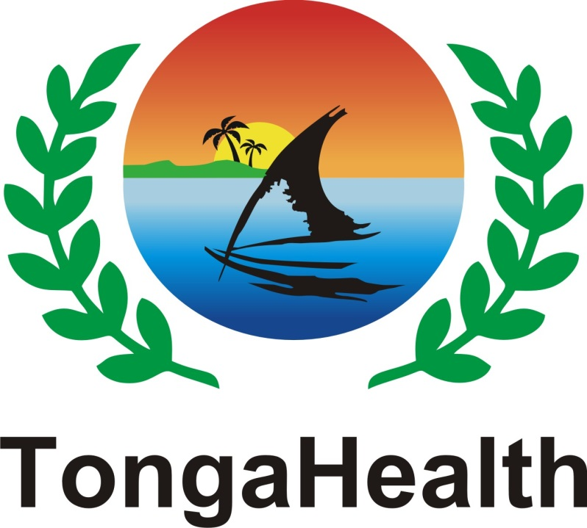
TONGA HEALTH PROMOTION FOUNDATION

STATEMENT OF CORPORATE INTENT
2016-2017

Promoting an Active and Healthy Tonga

CONTENTS

1. EXECUTIVE SUMMARY…….………………………………………………………….….3
1.1 Background 3
1.2 New Governance Model for NCD Control and Prevention 3
1.3 Scope of Activity 2016-17 4
1.4 Budget 2016-17 4
1.5 Governance 5
2. CORPORATE INTENT 5
3. LEGAL FRAMEWORK 6
4. NATURE AND SCOPE OF ACTIVITIES 6
4.1 Advisory Committees 6
4.2 Reducing Harm from Tobacco 6
4.3 Promoting Physical Activity (PA) 7
4.4 Promoting Healthy Eating 7
4.5 Alcohol Harm Reduction 8
4.6 Monitoring and Evaluation 8

4.7 Research Activities…………………………………………………………………….8
4.8 Operations of TongaHealth 9
5. OUTPUTS……………………………………………………………………………... 10

1 EXECUTIVE SUMMARY

1.1 Background

The Tonga Commitment 2003 marked Tonga’s recognition of the urgency to prevent Non-Communicable Diseases (NCDs) which led to the development of the first National NCD Strategy 2004-2009.

Tonga signed the WHO international Framework Convention on Tobacco Control in 2005.

Tonga Health Promotion Foundation (TongaHealth) was established in 2007 through the Health Promotion Foundation Act to address the NCD crisis in Tonga.

TongaHealth is a milestone marking Tonga’s commitment and response to the global NCD crisis.

In February 2010, the second National Strategy for the Prevention and Control of Non-Communicable Diseases (2010 – 2015) was launched. The third National Strategy for Prevention and Control of NCDs 2015-2020 was launched in February 2016.

The reduction in morbidity and mortality due to NCDs in Tonga is included as a target of the Tonga Strategic Development Goals (TSDG) for Tonga 2015- 2025. Outcome 2.6 states, “ A stronger and more integrated approach by all parts of society to address non-communicable disease”. TongaHealth supports targets identified by the government of Tonga to contribute to this National Outcome. TongaHealth embraces the theme to strive for a “Healthy Tonga; everyone’s business”, and commits to coordination of integrated efforts to put a halt to the rise in NCDs, through the National NCD Strategy and alignment with the Tonga Strategic Development Framework (TSDF) for 2015-2025.

The long term outcome of the National NCD Strategy 2015-2020 is the incidence and prevalence of NCDs is reduced.

1.2 New Governance Model for NCD Control and Prevention

Reviews of the National NCD Strategy 2010-2015 revealed the critical need for appropriate governance and infractructure to facilitate and coordinate implementation of activities through a multi-sectoral partnership system. It required a multi-sectoral entity outside of any Ministry reporting to Cabinet but has multi-sectoral engagement. In January 2015, TongaHealth assumed the role of secretariat for the National NCD Committee under a signed Memorandum of Understanding with the National NCD Committee. As such, TongaHealth will be responsible for coordination of the implementation of activities, source and manage funds and monitoring and evaluation of activities.

1.3 Scope of Activity 2016-17

The scope of activity for 2016-17 is guided by the Tonga Health Promotion Foundation Act 2007 (the Act), the Tonga National Strategy for the Prevention and Control of NCDs (Hala Fononga) 2015-2020, TongaHealth’s Strategic Plan 2016-2020 and the Memorandum of Understanding signed by the National NCD Committee and TongaHealth in January 2015.

TongaHealth focuses on developing effective partnerships, advocacy for healthy lifestyle policies for all settings, managing evidence based grant schemes and sponsorship programs as well as strengthening existing information management systems.

In addition to facilitating development of the National NCD Strategy 2015-2020, TongaHealth will seek to ensure inclusion of Gender, Equity and Social Inclusion (GESI) as a cross cutting issue to promote accessibility to health promotion activities and relevant health services for marginalized groups in Tonga.

TongaHealth will ensure development of Gender, Equity and Social Inclusion (GESI) as a cross-cutting issue to promote greater equity of access to health promotion activities and health services for marginalized groups in Tonga.

While the main focus will be in Tongatapu TongaHealth will also maintain and extend operations in Vava’u and expand to the Outer Islands of Ha’apai, ‘Eua and the two Niuas subject to availability of resources. TongaHealth is now in its 8th year of operation. It is imperative that disease prevention and health protection efforts are strengthened to reach a larger part of the Outer Islands to achieve or improve on some of the international goals that Tonga signed to.

With the increase in scope of activity, TongaHealth needs to increase staffing capacity from 6 to 11.

1.4 Budget 2016-17

TongaHealth has signed a Memorandum of Understanding with the Government of Tonga in relation to government funding. Recurrent funding from the Government of Tonga for 2016-17 is budgeted to be $500,000.

The total spending for 2016-17 is estimated to be $1,169,451. Funding will be sourced from the Tonga Government (40.8%), DFAT (54.3%), and a bequest to TongaHealth (4.9%). The total expenditure consists of 59.2% on Grants for implementation of the National NCD Strategy, and 25.8% on operational costs. The income from the Dr Tapa Funds is reserved for capacity development in Health Promotion or Public Health.

1.5 Governance

The general direction and supervision of TongaHealth is vested in its Board of Governance.

TongaHealth Board of Governance members are:

1 representative of Churches or Communities – Rev Dr Tu’ipulotu Katoanga (Chairman)
2 Health experts – Dr ‘Amelia Tu’ipulotu and Dr Reynold ‘Ofanoa
1 Member of the Legislative Assembly – Honourable Sosefo Fe’aomoeata Vakatā
1 Management/Business/Law expert – Mrs Leta Kami

TongaHealth is charged with the responsibility of administering the Tonga Health Promotion Fund (the Fund) in accordance with the Act.

The functions of TongaHealth include the making grants from the Fund for activities, facilities, projects or research programs related to the promotion of good health, safety and the prevention and early detection of diseases.

S15 (3) of the Act provides that the Fund’s monies may be derived from:

(a) money appropriated by the Legislative Assembly for that purpose;
(b) appropriate revenue measures as agreed by the Minister of Finance and the Minister of Health from time to time;
(c) bequests, donations and grants
(d) any other income or payment due to the Foundation

The role of the Board, acting on behalf of the Minister of Health, is to govern TongaHealth so that it fulfills its statutory responsibilities, whilst acting ethically and prudently and remaining within the law.

2. CORPORATE INTENT

The corporate intent of TongaHealth is to:

- advocate for healthy public policy and environments
- strengthen the capabilities of organisations, communities and individuals to achieve and maintain health
- work in partnership with others to achieve these goals
- fulfill its roles specified in the Memorandum of Understanding signed with the National Non-Communicable Diseases Committee in January 2015.

TongaHealth’s functional responsibilities, as set out in the Act, are to:

(a) act as the guardian of the Fund;
(b) make grants from the Fund for activities, facilities, projects or research programs related to the promotion of good health, safety and the prevention and early detection of diseases;
(c) keep statistics and other records relating to the achievements of the Foundation;
(d) provide advice on matters referred by the Minister to the Foundation and matters which are relevant to the operation of the Foundation;
(e) consult regularly with relevant Government Departments and agencies and to liaise with persons and organisations affected by or who may have an interest in the operation of the Foundation;
(f) seek and secure funds for the Foundation; and
(g) perform such other functions as are conferred on the Foundation by the Act or any other Act.

3. LEGAL FRAMEWORK

The Act provides the legal framework for the operation of TongaHealth.

S4(4) of the Act states that the Public Enterprises Act 2002 does not apply to the Foundation.

S17 of the Act specifies that no tax, duty, levy or government impost shall be payable by the Foundation on Fund monies.

S24 of the Act states that any bequest, donation or grant made to the Foundation or the Fund shall be deemed to have been made for a charitable purpose.

4. NATURE AND SCOPE OF ACTIVITIES

4.1 Advisory Committees

To support the implementation of the National NCD Strategy the four NCD Advisory Committees will advise:
  - the TongaHealth Board and, through the TongaHealth Board, the National NCD Committee on evidence, policy and planning issues relating to physical activity, health eating, tobacco control and alcohol misuse
  - the assessments by the TongaHealth CEO and staff (subject to delegation levels) on the efficacy of programs/projects seeking partnerships grants and making recommendations to the TongaHealth Board for approval
  - the management and support of partners and stakeholders
  - ongoing support of advocacy strategies in relation to promoting the goals of the Strategy

4.2 Reducing Harm from Tobacco

TongaHealth will work with partners like the Tobacco Control Unit of the Ministry of Health, the Ministry of Revenue and Customs, Ministry of Police, the Attorney General’s Office and other organisations in the implementation of the National Strategy relating to the reduction of tobacco related harm.

TongaHealth will support legislation to reduce demand for tobacco products and exposure to second hand smoke, as well as reduce the supply of tobacco products.

TongaHealth will support Smoke Free Campaigns and World No Tobacco Day events.

TongaHealth will encourage and support research on any knowledge gaps identified in the area of Tobacco Control.

TongaHealth will work collaboratively with the Ministry of Health Tobacco Control Unit on a social marketing campaign that will be commissioned with a focus on increasing intention to quit, reduce uptake and educate on the dangers of second hand smoke.

TongaHealth will gather evidence on the health impact of kava use in Tonga, as part of the implementation of the National NCD Strategy.

4.3 Promoting Physical Activity (PA)

The planned activities for 2016-17 include supporting the implementation of the National Strategy, for more Tongans meeting the WHO Global Physical Activity Guidelines ¹. The Global recommendations for children and adolescents aged 5-17 years is at least 60 minutes of moderate - to vigorous-intensity physical activity daily.

TongaHealth will support implementation of activities to increase the accessibility and affordability of physical activity, as well as increase demand for physical activity. Partners who will implement these activities include the Ministry of Internal Affairs, Ministry of Education and Training, and Ministry of Health.

4.4 Promoting Healthy Eating

The planned activities for 2016-17 include supporting the implementation of the National NCD Strategy that encourages Tongans to eat healthier diets.

TongaHealth will support activities to halt the number of babies exposed to the risks associated with being born to a mother with diabetes (GDM or Type 2), as well as activities to improve infant and toddler nutrition.

TongaHealth will aim to increase the availability, affordability and consumption of healthy food and reduce the availability, affordability and consumption of unhealthy food, as well as increase demand for healthier food/diets and reduce demand for unhealthy foods.
TongaHealth will develop more partnerships to promote healthy eating behaviours in schools, work places and communities. TongaHealth will continue its advocacy efforts to improve public policy to support healthy eating behaviours, advocate for legislative controls, and taxation of unhealthy foods.
¹ http://www.who.int/dietphysicalactivity/factsheet_recommendations/en/

Partners who will implement activities in this part of the National Strategy include the Ministry of Agriculture, Food, Forestry and Fisheries, the Ministry of Education and Training, Ministry of Revenue & Customs, Nishi Trading, and the Commercial and Business Sector.

TongaHealth will continue to support World Food Day on 16 October and World Diabetes Day on 14 November of every year.

4.5 Alcohol Harm Reduction

TongaHealth will support the implementation of the Alcohol reduction related harm strategy through funding advocacy work with the Liquor Licensing Authority for improved public policy, enforcement of legislation and support the Don’t Drink Drive campaign that the Ministry of Police leads. TongaHealth will support activities that reduces the supply of alcohol, reduces the demand for alcohol, establish a reliable evidence base on alcohol consumption patterns, and ensure relevant legislation is effectively enforced.

4.6 Monitoring and Evaluation

TongaHealth aims to gain accurate and timely information on the impacts and outcomes of TongaHealth programs as per the TongaHealth Monitoring and Evaluation Framework. It will work to strengthen its database to capture all the necessary information for analysis and reporting. TongaHealth has recruited a Monitoring and Evaluation Manager and a Monitoring and Evaluation Officer to carry out this important task. Once the M&E Framework is finalised, TongaHealth will work with implementing partners to report data and statistics required for monitoring and evaluation of programs. If there are challenges with partners non-compliance with reporting timelines, TongaHealth will step in to help identify the challenges and build up the capacity of partners to deliver reports and statistics.

TongaHealth will report annually to the National NCD Committee and the Minister of Health on program impact, lessons learnt and program evaluation. This report will be shared with stakeholders and taken into account in program development.

4.7 Research Activities

It is vital for TongaHealth to conduct research to provide baseline data and evidence to support the implementation of the National NCD Strategy. In 2016-2017, TongaHealth will support and fund the following research: Post Anti-tobacco campaign survey; STEPS Gap survey, Global Health School Survey; a Nutrition analysis of the Household Income and Expenditure Survey data; and analysis of the Population Census 2016 data on consumption of kava Tonga and tapaka Tonga.

4.8 Operations of TongaHealth

TongaHealth operations depend on good governance, good management and robust systems to be in place. Tongatapu is the central operation site for TongaHealth’s work throughout the country. But operations will expand to other island divisions during 2016-2017, and the next 3 years.

All current TongaHealth policies will be reviewed to ensure they are up to date and relevant.

TongaHealth will develop and implement a Plan to increase the funding pool of TongaHealth.
To improve reporting and recording of statistics, TongaHealth will review its IT systems, data base and equipment.

The new office extension will be constructed and completed in 2016-2017. Once completed, staff will move to this new office extension while the old one is refurbished. The new office extension includes a conference room which will be furnished, and reserved for Board meetings, meetings with implementing partners and staff meetings.

TongaHealth will strengthen its monitoring and evaluation component. A review of the current grants database will be conducted and strengthened to efficiently report all the work of TongaHealth.

A training plan will be implemented to build the capacity of, and up-skill, all staff. Mentoring of staff will continue. All efforts will be made to implement the Capacity Development Plan 2015-2020 as well as build a training plan for partners and organizations to improve capacities of partners to manage their programs and grants or sponsorships successfully. The Dr Tapa funds will continue to be utilized for capacity building in areas of health promotion and public health in partnership with the Ministry of Health, Public Health division. One new Driver position will be recruited in 2016-2017 to drive and oversee maintenance of the two TongaHealth vehicles. TongaHealth will continue to recruit two Australian Volunteers to help with the Grants Administration as well as the financial team.

TongaHealth’s public profile will be further developed through Communications and Marketing strategies. A Communications Plan will be developed to increase public awareness of TongaHealth work and how it contributes to national health development and the National NCD Strategy.

TongaHealth will continue to build international connections with other Health Promotion Foundations through attending trainings, exchange of Foundation experiences and practices and attending meetings or conferences of the International Network of Health Promotion Foundations and affiliations of which TongaHealth is a member.

TongaHealth will attend the 16th Annual Meeting of the International Network of Health Promotion Foundations in Melbourne in November 2015.

5.0 OUTPUTS

- The primary output for TongaHealth in 2016-2017 will be grants and sponsorships to implementing partners for the implementation of the National Strategy for prevention and control of NCDs 2015-2020. Grant Agreements will be developed in association with all relevant partners, with workplans and budgets to fully operationalise the National Strategy. This will include working closely with the NCD Adviser based in the Health Promotion Unit of the Ministry of Health, in accordance with the plan, and the development of new systems to support appropriate partnership agreements across sectors. The requirements of the DFAT Agreement signed with TongaHealth will be incorporated into the Grant Agreements, to ensure compliance of grantees with these requirements.

Other outputs will include:

- A robust Monitoring & Evaluation Framework to support the implementation and impact of the National Strategy for prevention and control of NCDs 2015-2020

- Annual workplans and budgets developed with partner organisations who will implement the National NCD strategy for prevention and control of NCDs 2015-2020.

- At least one partnership agreement with the relevant Ministries represented by the NCD Advisory Committees

- One round of grants

- One round of sponsorships

- Robust information management systems and governance in place

- Development of a plan to increase and diversify TongaHealth funding sources

- Implementation of the capacity development plan

- Review of all TongaHealth policies

